**DAILY REPORT**

**Student Name :SINDHU.N**

**Class and Sec : VI B**

**USN :4AL17CS094**

**DATE:03-08-2020**

|  |  |  |  |  |
| --- | --- | --- | --- | --- |
| **Online Test Details** | | | | |
| **Subject** | ------ | | | |
| **Semester** | VI -B | | **Duration** | ----------- |
| **% of marks** | | ---- | | |

|  |  |  |  |
| --- | --- | --- | --- |
| **Certification Course Details** | | | |
| **Course** | Cyber Security | | |
| **Certificate Provider** | Great Learning | **Duration** | 5.5hours |

**Snapshots of the daily class acitivities .**



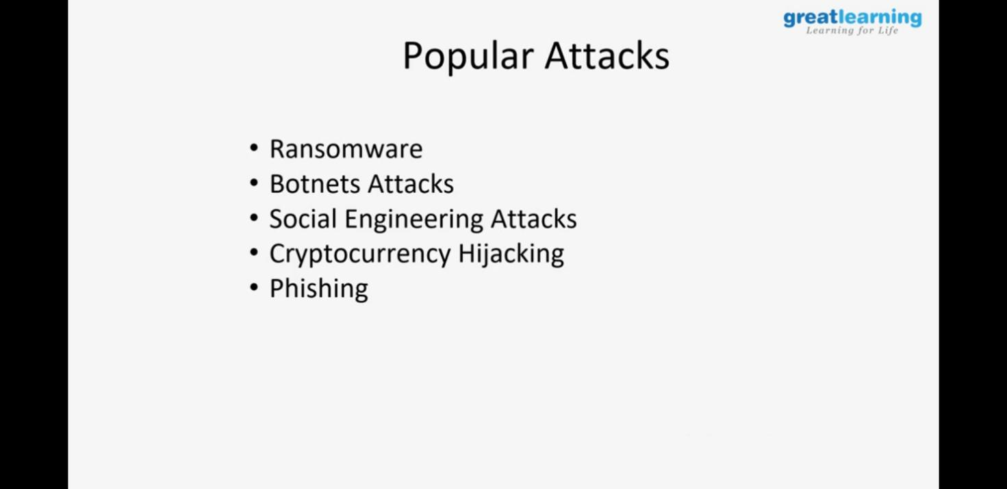

|  |  |
| --- | --- |
| **Coding Challenges** | |
| **Problem Statement:** 1.**Python Program for Number of jump required of given length to reach a point of form (d, 0) from origin in 2D plane.** | |
| **Status:** Executed | |
| **Uploaded the report both in Github & Slack** | Yes |

**Snapshots of your response to challenge.**

****1.Python Program for Number of jump required of given length to reach a point of form (d, 0) from origin in 2D plane****

def minJumps(a, b, d):

temp = a

a = min(a, b)

b = max(temp, b)

if (d >= b):

return (d + b - 1) / b

if (d == 0):

return 0

if (d == a):

return 1

return 2

a = 3

b = 4

d = 11

print (int(minJumps(a, b, d)))

**OUTPUT**

